Industry Partner Database

Sailesh Rajanala#1, Priyanka Limbu#2, Subash Acharya#3, Shiva Karki#4

#EECS Department, Wichita State University  
1845 Fairmount St, Wichita KS, 67260, USA

1sxrajanala@shockers.wichita.edu

2pxlimbu@shockers.wichita.edu

[3sxacharya5@shockers.wichita.edu](mailto:3sxacharya5@shockers.wichita.edu)

[4sxkarki6@shockers.wichita.edu](mailto:4sxkarki6@shockers.wichita.edu)

Abstract— This document provides information about Industry Partner Database, created by Team Lotus for Wichita State University. Research Results, Design Efforts, Development Challenges, Algorithm Analysis, and Technical Innovations related to the project are discussed in this document. This document also contains information about modern programming practices and innovative coding techniques in the field of Web Design and Development.

Keywords— Database, University, Webpage, Industry, Contacts, Web Design, Web Development, JavaScript, HTML, CSS, PHP

1. Introduction

Industry Partner Database is an online database that identifies and contains information about local Industry, Community, and Research Partners. Senior Design Instructors across all Departments of Wichita State University will use this project to gather Inter-Disciplinary Senior Design Sponsored Projects every semester. Universities need an online database to store and identify information about their local Industry Partners to establish relationships with the local industry which will help the university provide valuable opportunities for its students. Senior Design Instructors across different departments of the university have their list of Industry Contacts and these lists are in different formats specific to the department. Therefore, it is a challenge to unify the information across different departments of the university and store it in a unified database. Therefore, the project involves the creation of an online web page that operates on the data of an online database that is populated by a unified web form that Senior Design Instructors across different departments of the university use to gather Senior Design Projects by sending or advertising the form on university’s website where Industry Partners can access it to provide Senior Design Projects to Senior Design Instructors.

1. Project Related Work

The project is sponsored by Dr. Cindi Mason, Senior Design Instructor, ISME Department of Wichita State University. The team is always in constant communication with the Project Sponsor, updating them with the progress of the Project Work every week.

1. Understanding Core Values of the Project

The project comes with a responsibility similar to that of creating software. Therefore, it is very important to understand the core values of the project. For this, the team met with the project sponsor, before starting the project, to learn about the core values of the project which are as follows:

* Compatibility
* Sustainability
* Expandability

1. Compatibility: The project should be compatible with the existing web server of the university where the project will be deployed and must be friendly to other databases on the university’s server so that integration of the project with a different database is simple and easy.
2. Sustainability: The project should be sustainable and must be easy to be used by future generations. Moreover, the project should be future proof and should last at least 5 years
3. Expandability: Future developers who will work on the project should be able to expand the project with new features and functionality. All the project code that is written must include modules with high cohesion and low coupling.
4. Gathering Requirements

After understanding the core values of the project, the team started working on the compatibility aspect of the project by gathering the project requirements or understanding the domain of the project. The team then contacted the Media Resources Center of the university to gather the technical specifications of the university’s web server. The result of this work by the team led to the determination of the requirements of the project which are as follows: values of the project which are as follows:

* HTML 5, CSS 3, and JavaScript for webpages
* php 7.4 for web server
* MySQL, MariaDB 10.4.14 for the database

1. Research

For the team members to match their skill sets with the requirements of the project, the team has researched the requirements of the projects and the team members have enhanced their skillsets by utilizing the following web resources:

* For Front-End Development, the team has utilized online resources [1] [2]
* For server development, the team used PHP online manuals. [3]
* For developing the database management system, the team used MySQL online resources. [4]

1. Front-End Development: The team used the W3schools website [1] as a resource for learning front-end development. This is a very reliable resource as it contains the references for all front-end development technologies like HTML 5, CSS 3, JavaScript and it is very easy to use is it features an inbuilt code editor where users can execute the code online.
2. Server Development: The team utilized the classic PHP manual online [3] as well as w3schools as web resources for learning server development. php.net [3] is a good web resource, but it is not very easy to understand or simple to use for beginners whereas w3schools [1] is an extraordinary web resource that is beginner-friendly.
3. JavaScript Development: The team utilized developer Mozilla web resource [2] as a good resource for learning JavaScript and for functional programming using JavaScript.
4. Database Management System development: The team uses MySQL for Database Management System. Therefore, we used MySQL official website [4] as a reference for learning the MySQL language. The website is very user-friendly and simple to understand.
5. Project Description

The project involves two webpages, a web server, and a database. Therefore, it is very important to understand how data flows from one entity to another. On understanding the requirements of the project, the team has created a data flow diagram illustrating how data flows between different entities.

1. Data Flow

The primary collection of data occurs at the webform, which is created by using HTML, CSS, and JavaScript, on the university’s web server which the client or the Industry Partner has to fill and submit. On successful submission of the web form, the data submitted by the user is analyzed by the server, which is created using PHP, and then is sent to the database, the Database Management System created by MySQL will then store the submission as a record in the database. The dynamic webpage on the user’s end will retrieve the record from the database and displays it as a web element in the webpage created by using HTML, CSS, and JavaScript.

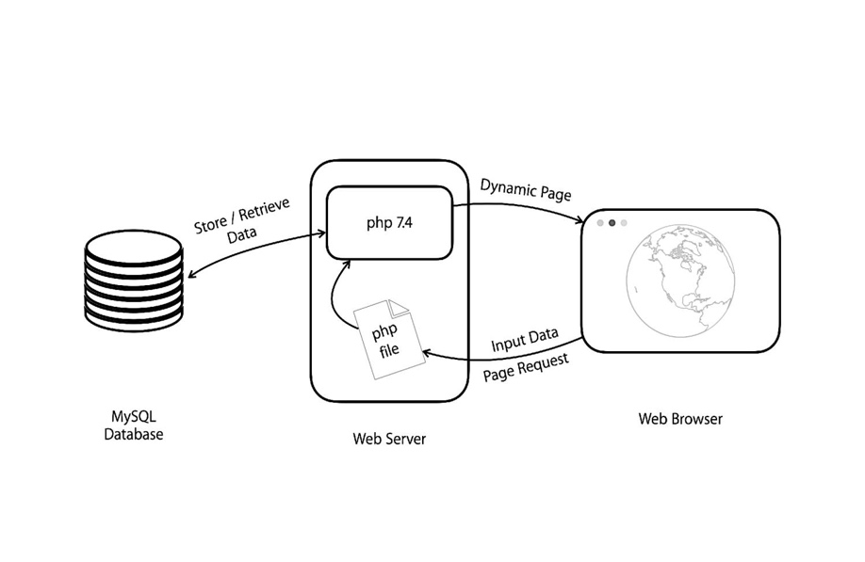

Fig. 1 Data Flow Diagram

1. Data Flow Algorithm – Data Entry

This is the algorithm that will be used between the web form and the database. The algorithm begins when the user starts to fill the web form and provide their information in different form fields of the web form. Different fields of the web form and then dynamically checked as the user types in information and this dynamic checking is done using JavaScript and is called Client-Side form validation. Therefore, Client-Side validation helps us to dynamically check the user’s input in real-time and also ensures that the user does not submit the form incorrectly or incompletely. Once the user submits the form, all the form fields are checked dynamically by the server and this is called a Server-side validation. During Server-side validation, the server created using PHP checks for any bad inputs or whether the user bypassed any of the security measures provided by the JavaScript during the client-side validation. If the server finds any bad inputs, the server then interrupts the form submission and displays an error message to the user stating, “Invalid form submission”. If the server does not find or come across any bad inputs, which means that the user’s input or user’s submission is valid, then the server approves the form submission and then checks for the existence of duplicate entries of the user’s submission. If the server finds any duplicate entries of the submission, which means that the user has already submitted the same submission with the same inputs previously, then the server interrupts the form submission and displays an error message to the user that states “Invalid form submission”. If the server does not find any duplicate entries of the form submission which means that this form submission is new and valid, then the server stores the record in the database. This is the algorithm for successful form submission and successful data entry into the database.

Fig. 2 Error Input Detection

1. Data Flow Algorithm – Data Departure

This algorithm will be used between the database and the webpage that will be used by the Senior Design Instructors to retrieve information from the database. This algorithm is simple. It begins with a webpage loading information from the database. The webpage initially presents the latest information or the information of form submissions on the present day. Following that, the webpage also shows older entries in divisions where there are 30 entries per division and only one division is displayed to the user at a time.

$sql = "SELECT " . $insertSchema . ", Timestamp FROM Contacts WHERE DATE(CONVERT_TZ(`Timestamp`,'+00:00','-06:00')) = DATE(CONVERT_TZ(CURRENT_TIMESTAMP(),'+00:00','-06:00')) ORDER BY Timestamp DESC";

Fig. 3 Data Retrieval Algorithm

1. Search Algorithm

In the dynamic webpage which senior design Instructors use, an important function of the webpage is to be able to search the database for records. The search algorithm should be simple but also powerful. It should be simple because it should allow future developers who will work on the database to easily understand and add the new functionality to it. It should be powerful so that it will allow the end-user to search a lot of records just by using a fraction of the search keyword. The Search algorithm begins when the end-user type in a keyword or a usual word in the search bar. The user’s input is now focused by the web server as it is with what the webserver compares with every all attributes of a record individually. The server checks for a match where the user’s input matches with any attributes of the record. This comparison or matching is case insensitive. This is done by changing the user input as well as all the attributes of the record to upper case and then comparing them. Once a match is found, the entire record is then displayed as one of the search results in the dynamic webpage. The team has utilized various web resources ([3], [4], [5]) that contains information about JavaScript and PHP to come up with an accurate searching algorithm.

SELECT DISTINCT " . **$insertSchema** . ",

Timestamp FROM Contacts WHERE **False** " .

'OR UPPER(First_Name)

LIKE UPPER(' . "'%{$_POST["searchBar"]}%') " .

'OR UPPER(Last_Name)

LIKE UPPER(' . "'%{$_POST["searchBar"]}%') " .

'OR UPPER(Email)

LIKE UPPER(' . "'%{$_POST["searchBar"]}%') " .

'OR UPPER(Phone_Number)

LIKE UPPER(' . "'%{$_POST["searchBar"]}%') " .

UPPER(' . "'%{$_POST["searchBar"]}%') " .

'OR UPPER(Notes)

LIKE UPPER(' . "'%{$_POST["searchBar"]}%') " .

'OR UPPER(Title)

LIKE UPPER(' . "'%{$_POST["searchBar"]}%') " .

Fig. 4 Search Algorithm

1. Export Algorithm

Exporting data is also an important feature of this dynamic webpage. This function works in two ways. The function is capable of exporting all records as well as only the search results from the database. The algorithm for exporting all records of the database is straightforward as the server goes through all records in the database and it prints all attributes of each record into a file created in the server itself and pushes the file as a download to the user’s local computer. This algorithm also applies to the search results when the user searches for a particular record. The file that is downloaded to the user’s local computer will be in “.xls” format.

header("Content-Type: application/xls");

$flag = **false**;

**while** ($row = $result->fetch_assoc())

{

**if** (!$flag)

{

**echo** implode("**\t**", array_keys($row)) . "**\r\n**";

$flag = **true**;

}

$copy = array_values($row);

**for** ($i=0; $i < count($copy); $i++)

{

$copy[$i] = str_replace("**\r\n**", "", $copy[$i]);

$copy[$i] = str_replace("**\r\t**", "", $copy[$i]);

$copy[$i] = str_replace("**\n**", "", $copy[$i]);

$copy[$i] = str_replace("**\t**", "", $copy[$i]);

}

**echo** implode("**\t**", $copy) . "**\r\n**";

}

Fig. 5 Export Algorithm

1. Results

On careful understanding of the core values of the project as well as on understanding the requirements of the project and by learning from various web resources to match the skill set of the entire team with the requirements of the project, the team has developed various prototypes. On creation of various prototypes and developing or updating them with the results of research performed by team members every week, the team has come up with a web form that is unlike any other web form, a robust database, and an easy to understand and simple to use User Interface for the dynamic webpage that will be used by Senior Design Instructors. During the development of each prototype, the team has come up with some innovative solutions to technical limitations and routine web programming practices basing on their research results which are as follows:

1. Combination of Radio Buttons and Checkboxes

It is common that many web forms in the world use radio buttons and checkboxes to get input from the user. If a web form contains a lot of checkboxes or a lot of radio buttons, it will be very hard for the user to select or review their selection among many list items. Radio buttons and checkboxes could have different functionalities in terms of programming but have the same functionality in terms of usage and in the minds of users. A radio button is used to select only one option whereas checkboxes are used to select one or more options among many options. If we try to understand their similarities, we can observe that they both have one thing in common, which is selection. Based on this idea, the team has come up with an idea to merge radio buttons and checkboxes. The result is a simple and easy-to-understand user interface for the web form. The user does not have to understand whether they are selecting a checkbox or a radio button, they simply have to select, and the webpage of the web form will, in turn, tell the user or allow the user to select one or more options. In other words, the user does not have to worry about the rules they have to follow while selecting an option. The team has utilized few web recourses ([6], [7], [8]) to understand radio buttons and checkboxes and to come up with an innovative solution of merging radio buttons and checkboxes.

Fig. 6 Checkboxes

Fig. 7 Radio Button

As you can notice from the Fig. 6 and Fig. 7, the radio buttons and the checkboxes look the same and it is very easy for the user to review their selection as the radio buttons and the checkboxes are highlighted when they are selected. Another important thing to notice is that the design of the radio buttons and the checkboxes is consistent and therefore it helps the user to easily identify their selections throughout the webform.

1. Recreating the functionality of the “other” option

In many webforms where there is a list of options to choose from, there’s always an option that says “other”. When the user selects the other option, they are prompted to enter their opinion or asked to create their own option among the list of options as their selection. Usually, when the user selects the other radio button or the other checkbox, they are then prompted with a different question and are asked to fill a text box. Therefore, the team came up with an innovative solution that is a simplification for this process that is to bind a radio button with a text box and a check box with the text box. With this approach, whenever the user selects the “other” option, which is a radio button or a checkbox, they instantly notice that the other option they selected is transformed into a text box with the placeholder “other” so that they can provide their input instantly.

This eliminates the need for a separate question, separate label, separate text box, and in general, a separate HTML element altogether and is very simple to understand for the user. This is powerful functionality made so simple for the user to understand. The user when using this user interface that is empowered with such functionalities, they don’t have to think or worry about how to use a simple web form correctly rather they simply have to follow their intuition and it is as easy as a click of a button, they get to see new features and all it takes is a blink of an eye to understand the functionality of a powerful user interface.

Fig. 8 Radio Button before selection

Fig. 9 Text Box after selection

Conclusion

Therefore, on developing various prototypes, by analyzing the requirements, and on understanding the core values of the project the team has created a reliable version of the prototype till date. By using some of the best programming practices, and by coming up with new and innovative solutions to age routine methods of programming, the team has created a modern, simple, and easy-to-understand user interface for the webpages involved in this project. As time progresses, the team will continue to understand and update the project with new functionality and reliable features to meet the needs of the Project Sponsor Dr. Cindi Mason as well as to create a unified and robust database for Wichita State University that identifies and contains information about Industry, Community, and Research partners.

References

1. “HTML,” W3Schools Online Web Tutorials. [Online]. Available: https://www.w3schools.com/. [Accessed: 22-Mar-2021].
2. “Resources for developers, by developers.,” MDN Web Docs. [Online]. Available: https://developer.mozilla.org/en-US/. [Accessed: 22-Mar-2021].
3. “Hypertext Preprocessor,” php. [Online]. Available: https://www.php.net/. [Accessed: 22-Mar-2021].S. Zhang, C. Zhu, J.
4. MySQL. [Online]. Available: https://www.mysql.com/. [Accessed: 22-Mar-2021].
5. Tom, Ankita, J. Carlos, G. Williams, Tao, J. Thomas, Zausiu, Sarah, Torres, Ghodmode, and B. Sher, “Welcome to The Art of Web,” The Art of Web, 15-Apr-1970. [Online]. Available: https://www.the-art-of-web.com/. [Accessed: 22-Mar-2021].
6. “HTML Dog: HTML Tutorials. And Stuff.,” HTML, CSS, and JavaScript Tutorials, References, and Articles | HTML Dog. [Online]. Available: https://www.htmldog.com/. [Accessed: 22-Mar-2021].
7. “A computer science portal for geeks,” GeeksforGeeks. [Online]. Available: https://www.geeksforgeeks.org/. [Accessed: 22-Mar-2021].
8. “freeCodeCamp.org,” Learn to Code - For Free - Coding Courses for Busy People. [Online]. Available: https://www.freecodecamp.org/. [Accessed: 22-Mar-2021].

Appendix

<https://github.com/SaileshRajanala/IndustryPartnerDatabase_TPR_Package>